**Career Plan Template**

**Format: Font: Verdana 12**

1. **Draw your road map or your career plan (30%)**

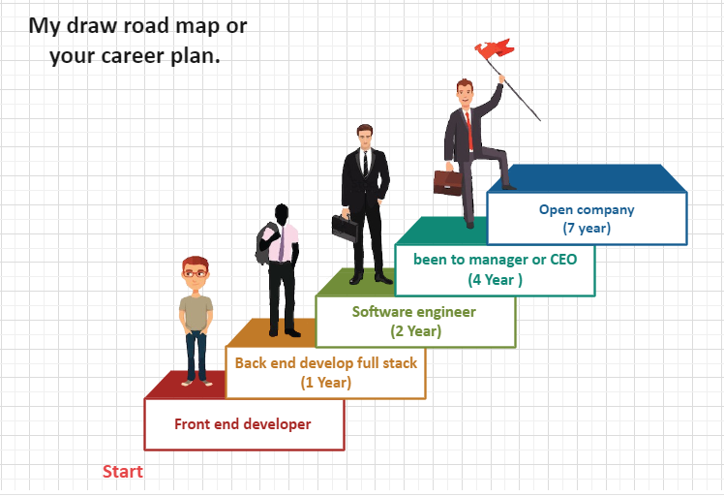

1. **Write reports with guidance questions (65%)**

|  |
| --- |
| 1. What is your professional goal? 15% |
| -> My professional goal is I want to do the front end development after completing the PNC. Also I want to do the front end and back end development at 2027. |
| 1. What are your strengths and weaknesses? 10% |
| -> My strengths are time management, research, sharing with others the new knowledge that I know, high responsibility in to do something, the tries to do the success if unsuccessful I’m not stop.  -> My weakness is that I do not speak much English, not good speaking to other, when learning I get the lesson slow. |
| 1. What kind of company do you want to work? And why? 10% |
| -> Company I want to do work is Cellcard.  - >Because there are skills that match my skills. Not only that, we have learned two new things, especially and the solution. |
| 1. How do you plan to update yourself? 10% |
| -> Plan to update myself are:  - Research a lot of than last  - Review lessons before going to internship  - Impure to on English are lessening, Speaking English and writing  - Impure to on OOP and Algorithm. |
| 1. How is the future of the IT job market? 10% |
| ->The future of the IT job market are:  - Strong growth  - There are many scholars in the IT  - Can help the society better. |
| 1. How do you adapt yourself to the IT job market? 10% |
| -> The adapt myself to the IT job market are:  - I look for mentors in companies that specialize  - Please the help form other  - Be friendly with the other  - Have a honesty in the job  - The time management in the job  - Take care of my own brain and body   1. – Smile a lot. |

1. Attach one JD of your ideal job (5%)

+ My JD of ideal job are:

* + Check map watch at the Phnom Penh
  + To do job web developer / front end
  + Job full time
  + To do job the solution
  + Salary.

